Paper title 14pt font size, single space, 12pt after
A. Author* and B. Author** (11pt font, single spacing, 6pt after)
*Address of author 1 + email address: name@domainname
** Address of author 2 + email address: name@domainname (10pt font, 14pt line exact spacing)

Abstract. A blank 11pt single space line should precede the abstract. The abstract should be written in a single paragraph of 100-200 words, 11pt Times New Roman, line spacing exactly 14pt. Do not put equations or references in the abstract. Do not include keywords. A blank 11pt single space line should follow the abstract.

1. Title of first section (11pt bold, exactly 14pt spacing, 3pt after)
Papers should be prepared using Word and submitted electronically as a “.doc” file to allow the editor to make minor corrections.
The first paragraph of a section and sub-section should not be indented. The line spacing should be 14pt exact; font Times New Roman 11pt. Use margins as in this document 2cm all round, gutter zero, A4 paper size. All text including the abstract but excepting reference list, figure and table titles should be left and right justified. Omit page numbers.
Second and subsequent paragraphs indented 0.5 cm. Do not leave blank lines between paragraphs.
Use Harvard referencing system e.g. Barlow and Hunter (1960). Avoid footnotes. Equations should be numbered consecutively, centred as below, and properly punctuated:
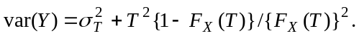 (1)
Where equations are not on a separate line but in the paragraph text as for example, 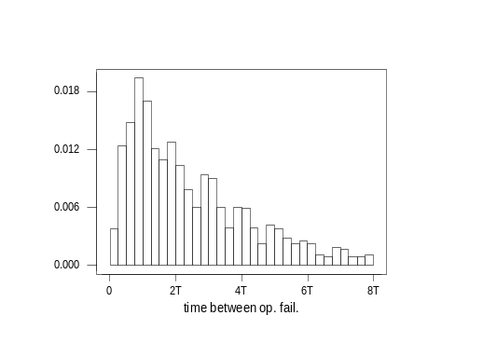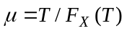, ensure that paragraph line spacing remains at exactly 14pt. Ensure equations’ font size is 11pt for main symbols, 8pt for subscripts, 6pt for sub-subscripts. Figure 1 shows an example figure.
Figure 1. Figure title centred below figure, 11pt font, 14pt exact spacing, blank 11pt single space line following figure title. Black and white only. Table titles should be the same, except for situation which should be above the table.

1.1 Sub section titles should be non-bold italic, spacing and size as section titles
Sub-sub sections should be avoided, but if necessary use same title format as subsections. A blank 11pt single space line should follow all section and subsection text.
Theorems and remarks should be formatted as follows:
Theorem 1. Format as text but with six pt before first line, six pt after last line.
Remarks should be likewise except that the remark title should be not bold but italic. That is:
Remark 1.
Regarding bulleted and numbered lists—please avoid them—but if they must be used they should be formatted as main text with bullet and number symbol against left margin as below,
- with text at 1cm indent on first and subsequent lines.
- Ensure that text in bullets is properly punctuated.

Appendix
An appendix should precede the references but follow acknowledgements section if applicable.

References
The reference list should be formatted as below. Book titles should be italised. Edited book or proceedings should be italised.
Barlow, R.E. and Hunter, L.C. (1960) Optimum preve..aintenance policies. Operations Research 8, 90-100.
Knuth D.E. (1981) Seminumerical Algorithms. Addison-Wesley.
Oaho, V., Ullman, J.D. and Yannakakis, M. (1983) On Notions of Information Transfer in {VLSI} Circuits. In Proc. Fifteenth Annual ACM Symposium on the Theory of Computing (Oz and Yannakakis, Eds.), Academic Press Boston, pp.151-158.

